BIG M PROBLEMS
1. Use penalty (or Big 'M') method to
Minimize z = 4x_{i} + 3x₂
subject to the constraints :
2x₁+ x₂ ≥ 10, -3x₁, + 2x₂ ≤ 6
x₁ + x₂ ≥ 6, x₁ ≥ 0 and x₂ ≥ 0.
Solution. Introducing surplus (negative slack) variables x₃ ≥ 0, x₅ ≥ 0 and slack variable x₄ ≥ 0 in the constraint inequations, the problem becomes
Maximize z* = - 4x₁ - 3x₂ + 0.x₃ + 0.x₄ + 0.x₅
subject to the constraints :
2x₁ + x₂ - x₃ = 10, - 3x₁ + 2x₂ + x₄ = 6
x_{l} + x₂ – x₅ = 6, x_{j} ≥ 0 Q(j = 1,2, 3, 4, 5)
Clearly, we do not have a ready basic feasible solution. The surplus variables carry negative coefficients (-1). We introduce two new variables A₁ ≥ 0 and A₂ ≥ 0 in the first and third equations respectively. These extraneous variables, commonly termed as artificial variables, play the same role as that of slack variables in providing a starting basic feasible solution.
We assign a very high penalty cost (say -M, M ≥ 0) to these variables in the objective function so that they may be driven to zero while reaching optimality.
Now the following initial basic feasible solution is available :
A_{l} = 10, x₄ = 6 and A₂ = 6
with B = (a₆ , a₄, a₇) as the basis matrix. The cost matrix corresponding to basic feasible solution is c_{B} = ( -M, 0, -M )
Now, corresponding to the basic variables A₁, x₄ and A₂. the matrix Y = B⁻¹A and the net evaluations z_{j} - c_{j} (j = 1, 2, .... 7) are computed. The initial basic feasible solution is displayed in the following simplex table :
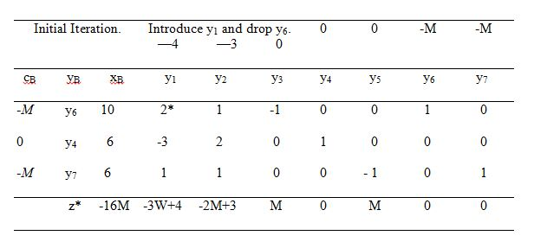
We observe that the most negative zj - cj is 4 - 3M (= z_{l} – c₁). The corresponding column vector y₁, therefore, enters the basis. Further, since min. = 5; the element y₁₁ (=2) becomes the leading element for the first iteration
First Iteration: Introduce y₂ and drop y₇.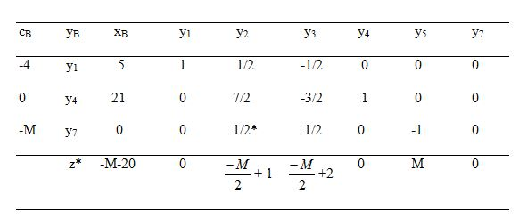
In the above table, we omitted all entries of column vector y₆, because the artificial variables A_{l} has left the basis and we would not like it to re-enter in any subsequent iterations.
Now since the most negative (z_{j}—c_{j}) is z₂-c₂; the non-basic vector y₂ enters the basis. Further, since min is 2 which occurs for the element y₃₂ ( = 1/2), the corresponding basis vector y₇ leaves the basis and the element y₃₂ becomes the leading element for the next iteration.
Final Iteration: Optimum Solution,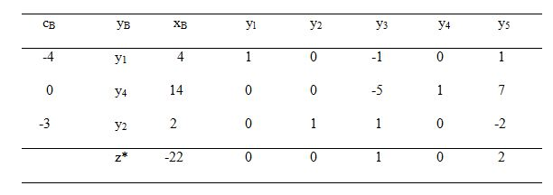
It is clear from the table that all z_{j} - c_{j} are positive. Therefore an optimum basic feasible solution has been attained which is given by
x₁= 4, x₂ = 2, maximum z = 22.
2. Maximize z = 3x₁, + 2x₂ subject to the constraints :
2x₁ + x₂ ≤ 2, 3x₁ + 4x₂ ≥ 12, x₁, x₂ ≥ 0.
Solution:
Introducing slack variable x₃ ≥ 0, surplus variable x₅ ≥ 0 and an artificial variable A₁ ≥ 0, the reformulated L.P.P. can be written as :
Maximize z = 3x₁ + 2x₂ + 0.x₃ + 0.x₄ – MA₁
subject to the constraints :
2x₁ + x₂ + x₃ = 2,
3x₁ + 4x₂ - x₄ + A₁ = 12
x₁, x₂, x₃, x₄ ≥ 0 and A₁≥ 0.
An obvious starting basic feasible solution is :
x3 = 2 and A₁ = 12.
The iterative simplex tables are :
Initial Iteration: Introduce y₂ and drop y₃.
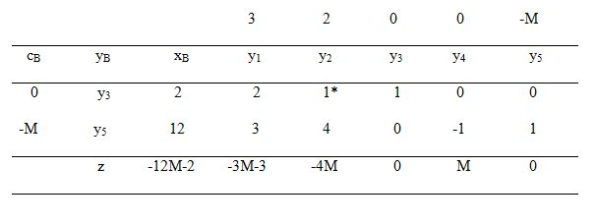Final Iteration. No solution.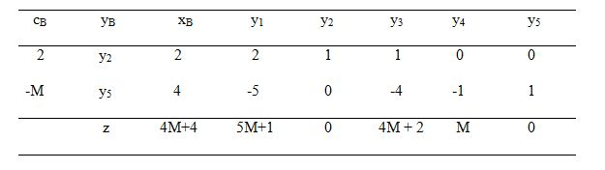
Here the coefficient of M in each z_{j} - c_{j} is non-negative and an artificial vector appears in the basis, not at the zero level. Thus the given L.P.P. does not possess any feasible solution.

